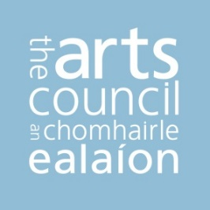

Arts Council Arts Activity Report

Arts Grant Funding – Forecast AAR

User Guide

Welcome to the Arts Council’s online arts activity report (AAR) portal. Before you begin to fill out the information required, we advise you to read this user guide carefully.
At the end of this guide you will find a glossary which gives explainers for the terms used.
IMPORTANT – note that the AAR site may time out if left unattended for a time. Be sure to save your work as you go to prevent losing any data.

NOTE: you should read the guidelines document on Arts Grant Funding and familiarise yourself with the overall process before reading this guide

Contents
1. Introduction 3
2. Logging On 4
3. Logging out 5
4. Select Application 6
5. Dashboard 7
6. Core Costs 8
7. Activities 10
8. Uploading your completed data set 17
APPENDIX – Glossary 18

- Introduction
The Arts Council’s arts activity report (AAR) portal is part of a project to gather data on the outcomes of our funding in a more efficient and effective way. This follows our commitment as part of the Developing Capacity goal within our ten-year strategy Making Great Art Work to develop our capacity in data and information so as to demonstrate the outputs and outcomes of our investments and to inform our advice and advocacy.
This User Guide gives instructions on how to use the AAR portal to enter and submit data in support of a funding application to the Arts Grant Funding programme. This is called the forecast arts activity report (F-AAR).
The information you provide in the AAR portal will be used as part of the assessment process for your funding application.
The forecast activity report is the first part of three reporting phases. Should your application for funding be successful, you will be asked to complete a budget arts activity report (B-AAR), which is where you will propose what you will actually do with any funding offered (this used to be known as providing a revised plan).
Lastly, when the activity or activities for which you have been offered funding are complete, you will be asked to complete an actual arts activity report (A-AAR) to tell us how those activities went.
As well as enabling us to understand how particular activities went, the totality of data provided will help to inform the Arts Council on the outputs and outcomes of our overall investments.
At this stage, you are just being asked to complete the first part of the process, the forecast AAR.
NOTE: Arts Grant Funding is open to both individuals and to organisations. Parts of this guide will be relevant to one, the other, or both.

- Logging On
Before you log into the AAR site, you first need to log into the Arts Council’s Online Services (OLS) site, https://onlineservices.artscouncil.ie. The OLS site is where you will select ‘Arts Grant Funding’ from the drop down menu of available funding*. Once you have selected Arts Grant Funding as an application, you can go to the AAR site to enter the data for that application. You should review and read carefully the guidelines document for Arts Grant Funding for information on the overall application process.
To access the AAR site, open your web browser and enter the address below. You will be presented with the login form into which you need to enter the ARN and password for yourself or your organisation (this is the same ARN and password that you use to access your account on the Arts Council’s Online Services website).
- Open a web browser and enter the following address: http://aar.artscouncil.ie
- Enter the ARN login details for yourself or your organisation
- Click the “Log in” button

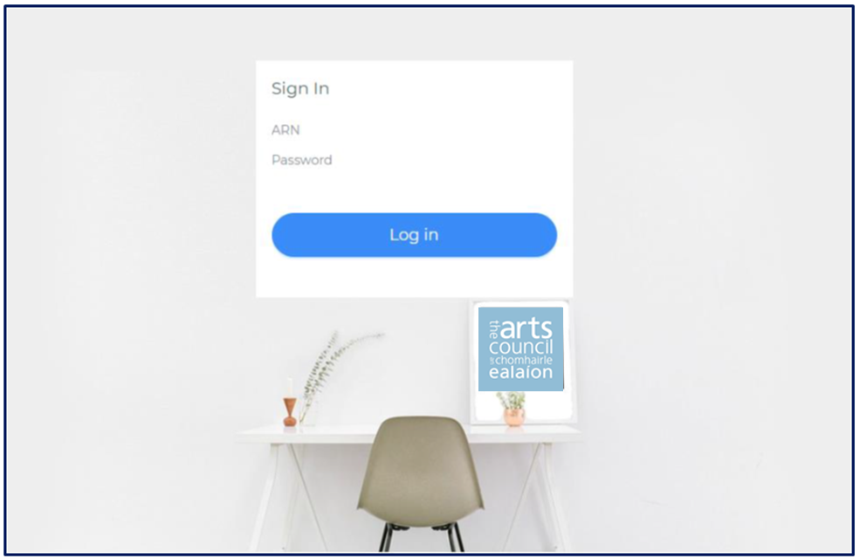

*NOTE: if you do not have an OLS account, you can get one by clicking on the ‘sign up’ button towards the bottom of the OLS homepage. Allow yourself plenty of time in advance of the funding deadline to do this, as it can take up to five working days for an OLS account to be set up.

- Logging out
To logout of the site click the Logout link at the bottom of the left hand navigation menu.
NOTE: be sure to save any data you have inputted before logging out. It will be there the next time you log in.

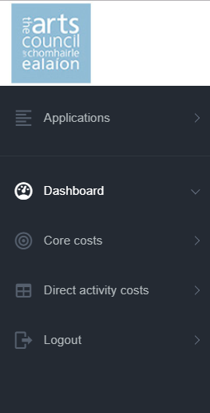

- Select Application
Once you have logged in you will see the application selection page of the site.
This page lists all of the applications for yourself or your organisation (for now, as the portal is new, there will only be one or very few applications. Over time, you will see historic funding applications).
Select the application that you want to enter data for by clicking on the ‘Select’ button to the right of the application number.
NOTE: at this point in the Arts Grant Funding process, the Application No. will read “To be allocated”. This is because you have not yet submitted the application through OLS. Nevertheless, you will now be able to enter data against this application.
APPLICATION NO.
FUNDING PROGRAMME NAME
SELECT
MENU

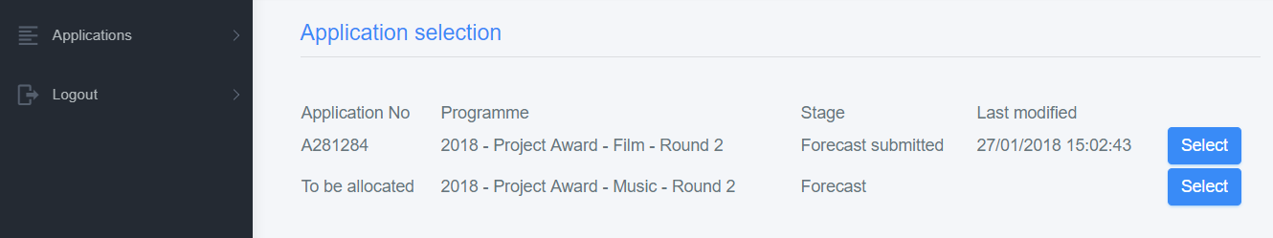
2018 – Arts Grant Funding - Dance

- Dashboard
Once you select the application that you want to work on, you will be brought to the dashboard for that application, called the “Arts Activity Report Summary”.
The dashboard shows the overall calculations for the application at the current stage in the AAR process. All of the figures on the page are calculated automatically. You cannot edit, click on or select any of the items displayed within the dashboard.
When you log in first, all of the amounts will be defaulted to zero. This is because you have not entered any figures yet. Once you begin to enter figures and save them, the dashboard will update. As long as you remember to save as you go along, figures you enter will remain visible in the dashboard even if you log out and log in again at a later point.
The ‘Requested amount’ will remain at zero until you enter a requested amount through the OLS website. This will then update in the AAR site.
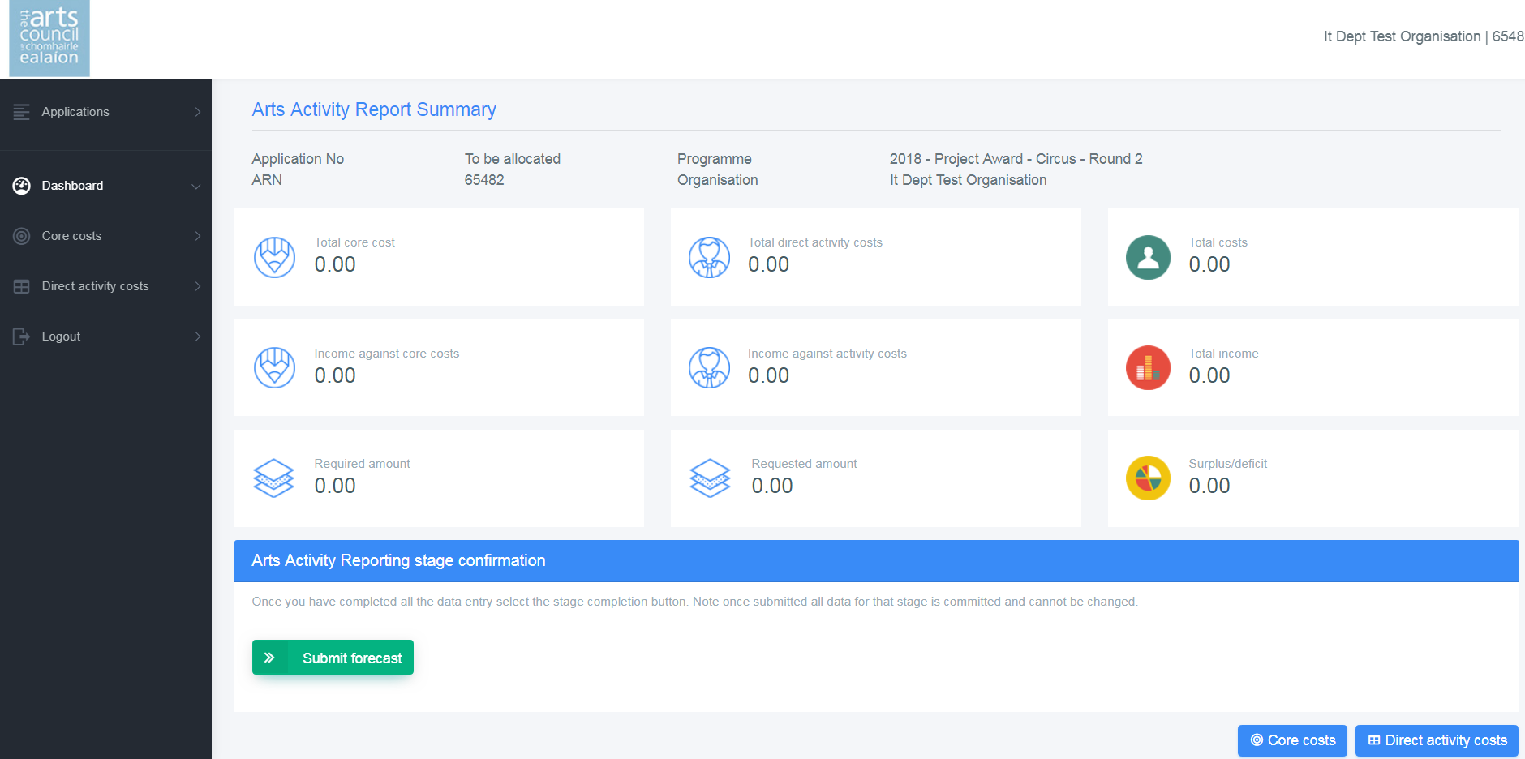

The figure to the bottom left of the dashboard is the ‘Required amount’. This is simply a calculation based on your total income minus your total costs.
The amount that you request should be equal to the Required amount, such that the Surplus/deficit figure is zero. We expect there to be no planned surplus or deficit at the application stage. You will enter the Requested amount in OLS, and, once you click back into ‘Applications’ at the top left of the navigation menu, and re-select the application you are working on, it will update the requested amount. Alternatively, you can log out of the AAR site and log in again. This will also update the requested amount.

- Core Costs
This is where you enter your core costs, should you have any. These are all costs directly associated with the day to day running of an organisation. If you do not have any core costs, you can leave this section blank, and move on to section 7, Activities.

NOTE: Some of the tool tips refer to ‘organisations’. These tips may also be relevant to you if you are applying as an individual in some cases.

The core costs for the application are displayed on this page in 3 different sections:
Section A: Core and administrative costs
Section B: Income not directly related to activity
Section C: Number of whole time equivalent staff
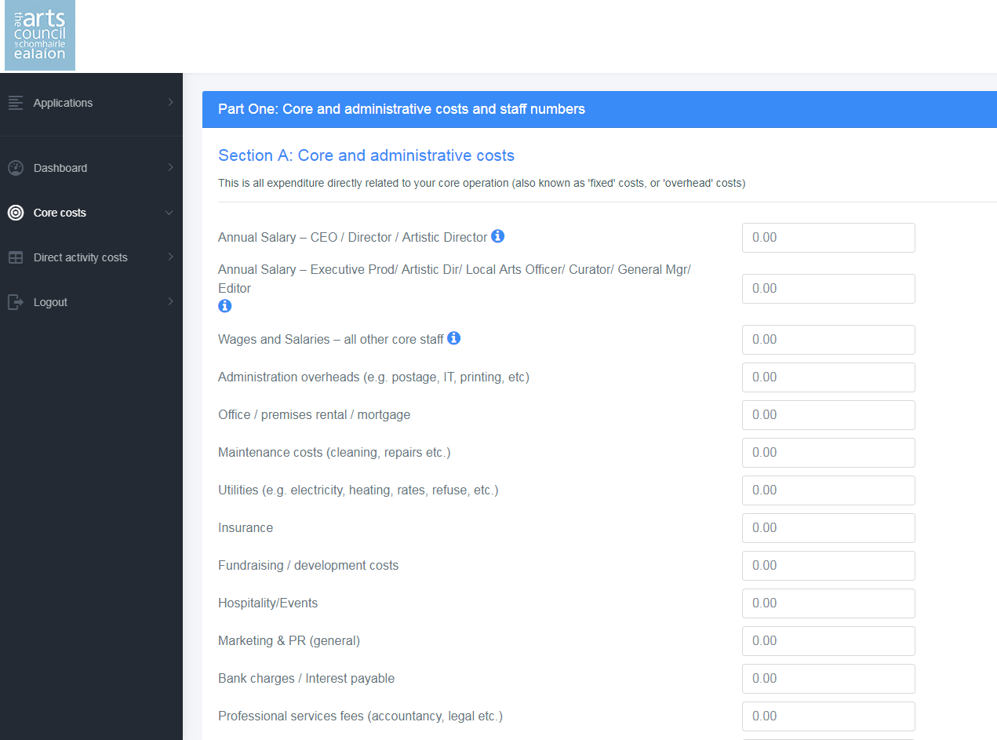

Section A: Core and administrative costs
Core costs – also known as overhead or operating costs – are any day-to-day costs associated with running your core business. These are costs such as, for example, staff costs, rent, mortgage, utilities, day-to-day administration, that have to be met irrespective of whatever specific arts activities are happening at any given time.
You should use the budget line items in the fields provided to list your core costs. It may be that not every budget line will match exactly the terminology that you use, but we ask that you do your best to match your own budget items to the items as given in the data.
NOTE: For the purposes of Arts Grant Funding, we expect any core costs associated with your proposal to be proportionate and appropriate to the activities proposed. Arts Grant Funding cannot be used to support ongoing organisational costs not directly related to the specific activities you are seeking support for.
If you are applying as an individual, you may not have any Core costs, and you can skip this section.
Section B: Income not directly related to activity
This is any income which comes into your organisation which is not directly attributable to specific artistic activities. This may be, for example, local authority grant funding, or sponsorship or fundraising which you are not attributing to a particular activity, but which rather you are setting against your day-to-day running costs.
Any income that is not directly attributable to specific artistic activities should go here.
NOTE: In the case of Arts Grant Funding, we would expect very little income not to be attributable directly to activities.
Section C: Number of whole time equivalent staff (WTE)
‘Whole-time equivalent’, (also known as ‘full-time equivalent’), is a unit that indicates the status of an employed person in a way that makes workloads comparable across various contexts.
A WTE figure of 1.0 will correspond to an employee who works full-time. An employee working half-time, therefore, would be 0.5, while an employee working, for example, four full days per week would be 0.8.
Using the examples above, one full time, one working four days per week, and one half time employee, would give an overall WTE figure of 2.3.
These figures should be broken out between artistic personnel and non-artistic personnel. If an employee’s role involves both artistic and non-artistic tasks, you can break out their role in proportion to how much time they spend on each. For example, a full time Artistic Director’s role might be 0.8 artistic and 0.2 non-artistic. Again, using the example above, this would give a total Artist WTE of 0.8, and a total Non-Artist WTE of 1.5.
It is not vital that this information is 100% accurate. You should give as close an approximation and break down of the information as you can. The purpose is to give the Arts Council an aggregated overview of the number of people employed on an ongoing basis through Arts Council-funded organisations.
Once you have completed all of your core costs, incomes not directly related to activity, and WTE numbers, you can select ‘Save’ at the bottom of the page. You can then click on ‘Dashboard’ to bring you back to the Dashboard, or ‘Direct Activity Costs’ to bring you into the direct activity costs page.
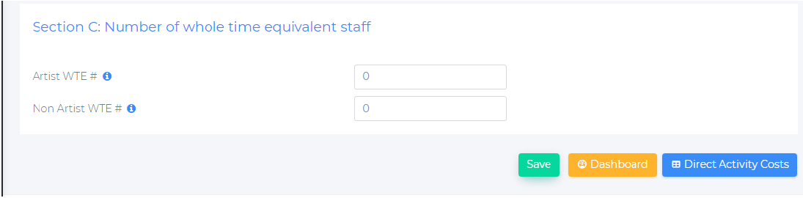
1.5
0.8

NOTE – it is very important to click the ‘Save’ button before moving on, otherwise anything you input will be lost.
- Activities
Once you have completed the Core costs section (or in the event that you don’t have any), you can move onto providing details about your proposed activities.
You can do this either by clicking on the ‘Direct activity costs’ button at the bottom right hand of the dashboard screen, or in the navigation menu on the left hand side of the screen.
We will look for different kinds of information on your activities:
- The direct costs associated with each activity
- The focus of the activity and who it is targeted towards
In addition, we will look for information on what we call the iterations for those activities. An iteration simply means the form that the activity will take.
In many cases, an activity will only have a single iteration. For example, if you are putting on an exhibition in a gallery over a set period, that would be a single iteration of that activity.
However if, for example, you are publishing a book in different formats, each format would be considered a different iteration of the same activity. For example, you might be publishing a book as a physical book, as an e-book, and as an audio-book. By itemising these three versions as separate iterations, you can share with us the sales targets and other details for each iteration.
Another example of multiple iterations would be the presentation of the same work in different locations. For example, if you are presenting a play in more than a single venue, then each venue or location at which you present the play would be an iteration for that activity. In this way, you can report on your audiences for each venue. This is essential to help the Arts Council to understand the audience for work that it supports on a national basis.
7.1 Direct Activity Costs
Activity costs are those costs directly related to your artistic and arts-related activities. To add a new set of activity costs, click on the ‘Add new activity’ button.
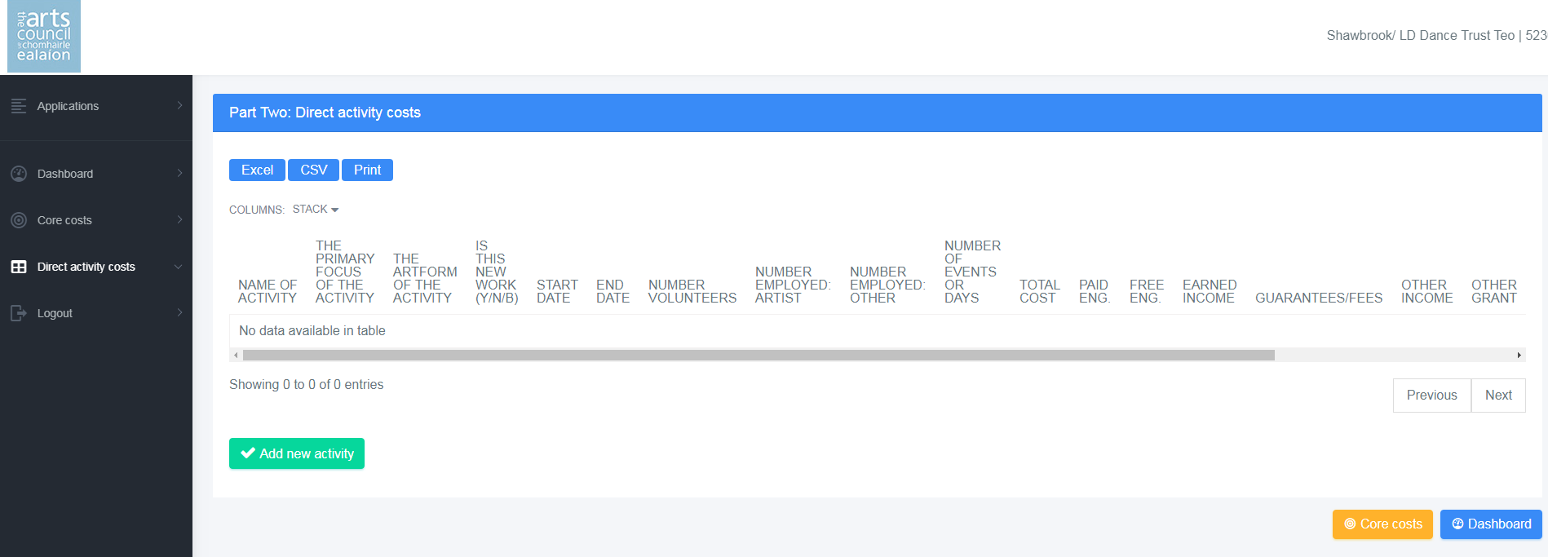
This will allow you to input details about that activity. You can also click on any activities already listed to edit them.

7.2 Activity detail
When you click ‘Add new activity’ or click on an already existing activity, you will be brought into a screen called ‘Activity detail’.
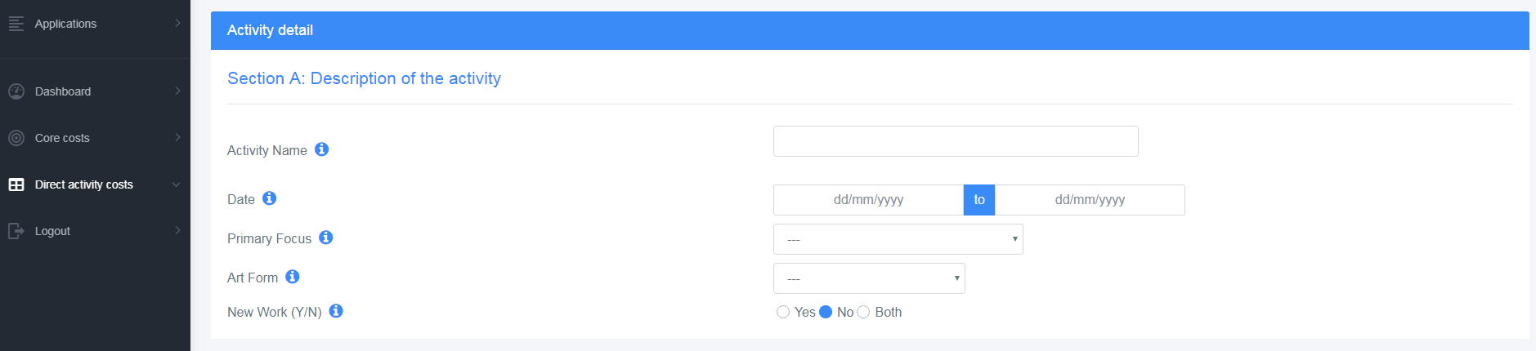
The activity detail asks information in four sections:
Section A: Description of the activity. This includes:
- The name of the activity
- The start and end date for the activity
- The primary focus of the activity
- The art form of the activity
- Whether the activity involves or includes the generation of new work
Section B: Employee numbers. This includes:
- The number of artists employed to deliver the activity
- The number of non-artists employed to deliver the activity
- The number of any volunteers involved in the delivery of the activity, where relevant
NOTE: the numbers employed within activities are not provided on a WTE basis. Each person employed or contracted should be listed simply as 1 person employed.
Section C: Financial Information
- These are the direct costs associated with the activity
Once you have entered the data for Sections A, B and C, you should click on ‘Save’ before moving on to Section D: Activity Iterations

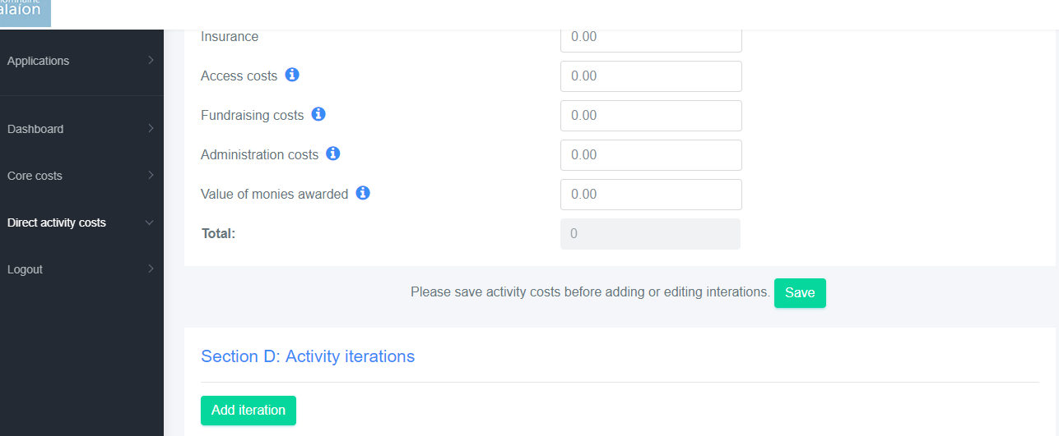

NOTE – again, it is very important to click the ‘Save’ button before moving on, otherwise anything you input will be lost.

7.3 Activity Iterations
As previously mentioned, ‘Iteration’ is the term we use to describe the form that an arts activity takes.
Each activity that you undertake will have at least one iteration. To create an iteration, click on ‘Add iteration’ at the bottom left of the screen.

You are asked to provide the venue where the activity will take place, if relevant. Once you start to type the venue name, if it is in our database of venues, it will auto complete. If you are presenting work or delivering an activity in a venue which is not listed on the Arts Council’s data base, you can click at the bottom of the screen to add a new venue and send us details of the venue. If the activity is not venue-based, type “N/A”.
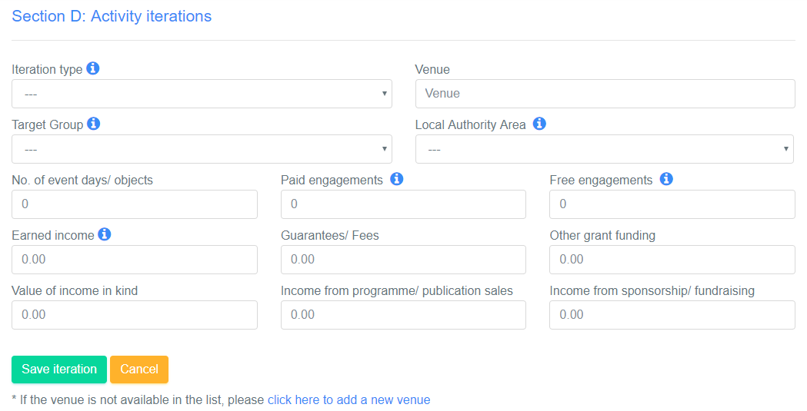

Once you have entered the details for the iteration, you should click “Save iteration” before moving on.
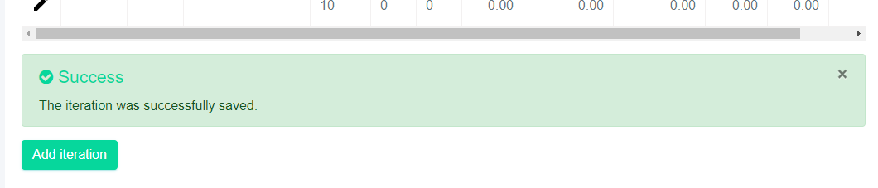
If an activity has more than a single iteration, you can provide that information by again clicking on ‘Add iteration’. This will allow you to enter another iteration for the activity if required. You can add as many iterations for a single activity as you like.
Once you have entered all of the iterations against an activity, you can save the iteration(s) and move onto the next activity.

Once you have saved activities and their iterations in the system, you can go back and edit them if you need to by clicking on the pencil icon to the left of the iteration.
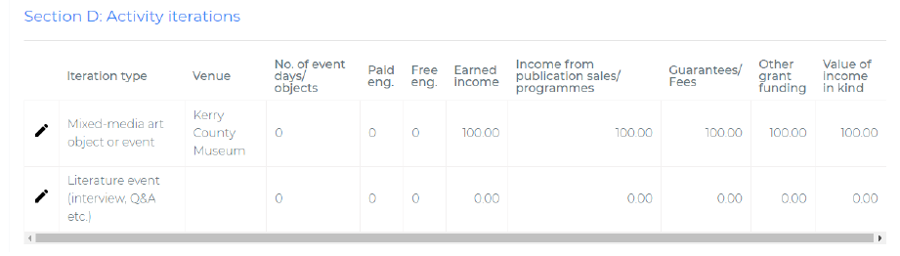
The details within each iteration you will be asked for will be:
- Iteration type – this might be, for example, a class, a workshop, a performance, a conference, a book, an exhibition or a showing, etc.. We have tried to make the list of possible types of iteration as comprehensive as possible. You should select the iteration type which most closely matches the activity you are proposing to undertake
- Venue – where will the activity take place? If you are not presenting the activity in a venue (or if is an activity that is not a performance or presentation, you can enter N/A)
- Target for activity – The specific audience, public, or group targeted by the activity
- Local authority area – what LA area will the activity take place within? (If the activity is regional, national or international, you can select one of these)
- No. of event days/objects – this is the number of performances of, for example, a dance music, or theatre piece, or the numbers of copies of a book being published. In the case of an exhibition, it should be the number of days that the exhibition is open to the public
- Paid engagements – this is the number of people engaging with the activity. "Engagement" in this context refers to any member of the public who watches, listens, reads, attends or otherwise engages with the activity. This would include the sales target – in numbers – for the sale of a book, publication, or other art object. It also refers to any member of the public, or artist, or practitioner who takes part in a workshop, class, or other participatory activity. "Paid" means that the individual has paid to attend/take part/purchase the art work or activity
- Free engagements – the same as paid engagement, except that there is no price paid. This might be, for example, a free outdoor event, or an art exhibition with no admission charge. If you are inviting guests to see your work, or to an opening night on complimentary tickets, you should include these here. Similarly, if you make copies of a publication available for publicity purposes or review, you should include that here
- Earned income – this is income earned through the sale of art objects, book publications, or tickets sold for performances or events
- Guarantees/fees – this is any income secured by means of guarantees of fees from presenting partners and/or co-producers
- Other grant funding – this is any income from other sources of grant funding (e.g. Arts Council Touring, Local Authority) that you are contributing to the cost of the iteration. (Note; if you presenting work in more than a single location, you can divide the amount across the locations where the work is being presented)
- Value of income in kind – this is the value of any support you are receiving in kind for your activity. Remember that this income should be matched in your costs
- Income from programme/publication sales – this is any income from sales of show programmes or catalogues for exhibitions. It is not income from the sale of books published as an activity in their own right.
- Income from sponsorship/fundraising – this is any income you are putting directly toward the cost of the activity which you have raised through fundraising.

A note on setting engagement targets
Paid engagements
You should be confident in setting your paid engagement targets for the year ahead that you can stand over the figures you provide.
Where your engagement numbers are recorded by means of a box-office system, you will be asked to use the data from that system to verify your audience numbers when it comes time to report on the outcomes of your activities at the end of the period for which funding has been awarded.
Where you are providing sales target figures, you will be asked to provide evidence of this as part of the actual report.
Free engagements
If your activity is free and does not involve a ticketing system, you should base your engagement targets on a verifiable method for collecting this type of data.
If you need guidance on how to calculate exhibition attendance, we recommend this report:
http://artsaudiences.com/wp-content/uploads/2013/11/Here-and-Now-Sketches-of-my-audience-2013-Public-Dissemination.pdf
Some examples of acceptable methods for outdoor/spectacle events are set out in the Irish Street Arts and Spectacle guide
http://www.isacs.ie/images/documents/ISACS-street-arts-handbook.pdf
In all cases, when projecting engagement numbers forward for the period ahead, we expect you to be both realistic (basing your projections on previous experience and/or other knowledge) and ambitious (looking to either increase your engagements, or deepen the engagement you may have). You will be asked in every case to use a verifiable system in reporting on the actual numbers of engagements, so it is important to make your projections as accurate as possible.
The Arts Council has produced a guide to setting an audience target which you can find here:
http://www.artscouncil.ie/uploadedFiles/wwwartscouncilie/Content/Arts_in_Ireland/Strategic_Development/How-to-set-audience-target.pdf

Online engagements
Where you or your organisation provides artistic experiences or services online, such as an online publication, downloadable or streamed art work, etc., you should include these in your engagement figures.
You may not include engagements either on- or off-line which are of a marketing nature, such as the number of unique visitors to your website, or numbers of people who sign up for a mailing list.

- Uploading your completed data set
The bottom section of the dashboard page is used to submit the data at each stage of the arts activity report process (F-AAR, B-AAR and A-AAR).
For the purpose of applying for Arts Grant Funding, you are submitting the forecast to go with that application.
To upload your data, click on the ‘Submit forecast button. Note, it is important that you only submit the ‘forecast’ at this stage*

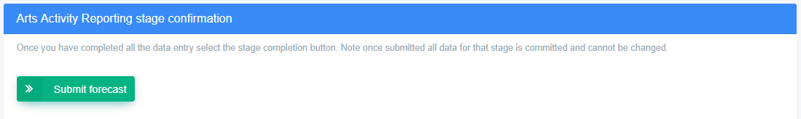

A pop-out box will ask you if you are sure you want to proceed. Assuming you are happy, click on ‘Submit’. The ‘Submit forecast’ button will then change to red and will read ‘Forecast complete”.

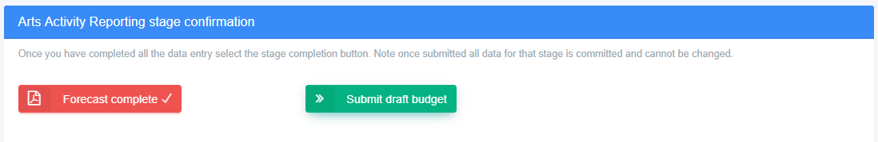

You will also see a ‘PDF’ icon to the left of the button which will allow you to generate a PDF of the data set you have created. You should click this PDF icon, open the PDF, and save it to your computer.
You must then upload this PDF through the Arts Council’s OLS website as evidence that you have completed this stage of the process.
You should keep the PDF for your records.

*IMPORTANT: at this stage, you are only being asked to submit a forecast. The information you submit will then be reviewed by Arts Council staff as part of the assessment for your application.

APPENDIX – Glossary

This glossary has been arranged alphabetically
Access costs | This is any costs associated with making your activity accessible to people with disabilities
Administration costs | This includes the costs of administering an award or scheme
Administration overheads (postage, IT, printing, etc.) | Day-to-day administration overheads associated with your operation
Amateur / voluntary practice | Work aimed at developing or encouraging involvement in arts activities by volunteers and/or non-professional artists
Amortisation of capital grants | Capital monies recognised as income over the useful life of the asset
Annual Salary – CEO / Director / Artistic Director / Local Arts Officer | The annual salary of the head of your organisation, including employers' tax and any pension contribution
Annual Salary – Executive Producer / Artistic Director / Curator / General Manager / Editor | The annual salary of the second-in-command of your organisation, or the AD if he/she is not the CEO
Archive/Preservation/ Collection | Costs associated with collecting or archiving art objects or material (for example, music scores, etc.)
Art Film | Experimental or non-narrative film
Arthouse cinema presentation | The showing of an arthouse film (which may be narrative based)
Artist’s book | A book made or conceived by an artist showing their work, often accompanying an exhibition of their work
Artist-focused activity | An activity which is designed to benefit practicing artists, such as, for example, a workshop or masterclass
Artists bursary/award scheme | An activity which involves running a bursary scheme for individual artists
Arts development activity | An activity which focuses on develop a new piece of art (for example, a rehearsed reading, a workshop etc.)
Arts in education | Activities delivered in an education context
Arts journal/magazine | A journal or publication on the theme of art
Arts Participation activity | An activity involving participation by non-professional artists or performers
Audio-visual art work | Any art work with an audio-visual element, such as video installation
Bank charges / Interest payable | Charges from you bank
Bar sales/merchandise | Income generated from bar sales or from the selling of merchandise, usually at an arts venue or theatre
Broadcast/streamed event | Any activity which is broadcast or streamed over the internet for public consumption
Capital costs | Costs associated with capital expenditure, usually to do with building works, large equipment, or refurbishment
Class | An arts activity involving teaching
Conference | An arts related conference or such event
Consultant / specialist / contract fees | The costs of experts contributing to the work of your organisation
Contingency | A provision made in a budget to allow for unanticipated costs
Dance performance | The presentation of a dance work to the public
Depreciation | The reduction in the value of an asset over time
Documentary | The creation of a filmed or sound recorded documentary
Donations/Gifts | Income earned through philanthropic giving
Earned income | This is any income earned through the sale of art works, or tickets for performances, including commissions on arts sales
Exhibition | The presentation of work or works of visual art to the public
Fees | The cost of hiring artistic personnel on a fees basis for the delivery of an activity, e.g. a lighting designer, choreographer, etc.
Fees for services | Income generated through delivering services to clients
Film event (interview, Q&A with screening etc.) | A public event related to the presentation or screening of a film, for example as part of a festival
Fundraising / development costs | Costs associated with running a fundraising campaign
Fundraising costs | This is costs associated with raising sponsorship or funds relating to a specific activity
Gallery exhibitions Arts sales commissions | Income earned through commissions on the sale of art works
Grant income - international | Any grant income received from international agencies or grant giving bodies
Grant income - Local Authority | Any grant income received from the local authority
Grant income - national | Any grant income received from national grant-giving agencies or bodies in Ireland, other than the Arts Council
Guarantees / Fees | Fees received for the presentation or production of work, such as, for example, when touring work to a venue
Hire costs (e.g. equipment, lighting, sound, etc.) | Costs associated with hiring technical equipment for the purpose of creating or delivering an activity
Hospitality/Events | Costs associated with hosting events such as opening night receptions, gallery openings, book launches, etc.
Income from programme / publication sales (e.g. show programmes, art catalogues, etc.) | Any income received through the sale of show programmes or brochures associated with art events.
Indoor or outdoor event or project in public space | Any activity taking place in a public space, such as a public building, a park, or on the street
Industry event | An arts activity aimed specifically at arts professionals
Installation | An art work designed for a particular room or place
Insurance | Cost of insurance
Interest receivable | Any interest earned though savings on deposit
International activity | Any activity happening outside Ireland
Literary journal/magazine | A journal or publication containing new writing
Literature event (interview, Q&A etc.) | A public event related to the written word, for example as part of a festival
Maintenance costs (cleaning, repairs etc.) | Ongoing costs associated with the upkeep of buildings
Marketing & PR (general) | Costs associated with general marketing and pr - not directly related to a specific arts activity
Marketing and PR costs | Costs associated with promoting a specific arts activity
Miscellaneous expenses | Sundry costs, petty cash, etc.
Mixed-media art object or event | A visual art work where more than one medium is employed
Multimedia art object or event | Usually a visual art work involving more than one form of media, moving image, sound, etc.
Music piece – downloadable / streamable | A recording capable of being downloaded for sale or use by the public
Music recital / performance | The performance of live music for the public
National tour / dissemination of work | Work touring on a national basis, or the dissemination of work by use of technology
Networking event | An industry event whose purpose is to foster networks and professional relationships and partnerships
Office / premises rental / mortgage | The rent or mortgage on the offices or venue of an arts organisation
Online art work | Any art work which is viewable online
Other Arts Council grant income (e.g. third party schemes) | Funding from the Arts Council other than direct grant funding, such as Touring
Oral/Spoken word performance | An activity involving the spoken word, such as storytelling
Per Cent for Arts Scheme | Income earned through the percent for arts scheme
Performance art - live | A piece of performance art performed live for the public
Performance art - recorded | A piece of performance art recorded for exhibition or dissemination
Physical Production costs | This is the cost of making or creating a piece of work, for example, physical production, making, creating, printing and binding, exhibiting costs
Play | The presentation of a play
Podcast | The production of a podcast
Policy initiative | An activity which may contribute to, or lead to the development of arts related policy
Presentation | The presentation of any type of art work
Professional services fees (accountancy, legal etc.) | Core costs associated with professional services
Public event – interview, Q&A etc. | Any activity involving a public interview and/or Q&A with an artist
Public event - reading | Public reading of literary work
Publication - Audio book | An audio-recording of a published book
Publication – Catalogue / programme | The catalogue or programme associated with a gallery exhibition
Publication - E-book | Electronic version of a published book
Publication - Online journal / magazine | An arts related journal or magazine published online
Publication - Printed book | A physical book
Publication sales | Income earned through publication sales which are related to your core or overheads.
Public-focused event | Any arts related activity aimed at the general public
Recording (CD/DVD/vinyl) | Any arts related recording, but usually music
Rental costs (e.g. studio, rehearsal space, etc.) | Costs associated with hiring space as part of the delivery of an arts activity
Rental income (Space/Equipment) | Income earned by renting out space
Research | Any arts related with research activity
Research project / or initiative | Any arts activity whose primary focus is research
Rights and royalties | Cost associated with the purchasing copyrighted material
Royalties received | Income earned through copyright
Screening | Presentation of art related work onscreen
Seminar | A meeting or event for discussion or training
Sponsorship/Fundraising | Income earned through sponsorship/fundraising activity
Storage rental / mortgage | Cost associated with storage space or facilities
Subscriptions/membership income | Income generated through membership fees
Value of income in kind | Services or resources other than cash which have a value which can be offset against costs
Theatre performance | Presentation of work in a theatre
Transport/accommodation/per diems | Costs associated with the costs of moving employees for the purpose of delivering an activity in more than one location
Travel and accommodation costs | Costs associated with travel and accommodation associated with your core activity, for example, an AD travelling to see work
Utilities (electricity, heating, refuse, etc.) | Heat, lighting bills etc.
Value of expenditure in kind | Services or resources other than cash which have a value which can are represented as costs
Value of monies awarded | This in cases where your activity includes the granting of awards or bursaries to artists
VAT payable | Any VAT owing on fees, purchases etc.
VAT receivable | Any VAT charged on activities
Visual art work | A piece of art characterised as visual art
Voice recording | Any arts related recording involving the human voice
Wages and salaries | The cost of hiring artistic personnel on a salary basis for the delivery of an activity, e.g. musicians, actors, dancers, stage management, etc.
Wages and Salaries – all other core staff | The core cost associated with permanently employed staff
Work for a general audience | Work not targeted a specific demographic or group
Work for a targeted audience | Work aimed at a specific demographic or group
Workshop | An arts related activity involving the development, generation or creation of ideas towards a piece of work
Youth Arts | Work associated with, involving, or aimed at, young people - usually outside a school setting

