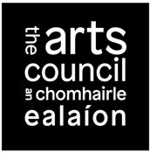

Arts Participation Bursary Aware Frequently asked questions
What is the objective of the Arts Participation Bursary Award?
The primary focus of the Arts Participation Bursary Award is on the artist and the exploration and development of the applicant's own individual artistic practice.
The award provides artists with the time and resources to think, research, reflect and engage deeply with their practice.
How does the Art Council define a professional artist?
The Arts Council defines a professional artist as an individual who identifies themselves, and is recognised by their peers, as a practicing professional artist. The applicant does not have to make their living exclusively through their arts practice.
Who is the Award open to?
The Arts Participation Bursary Award is open to individual artists who:
- Have a track record of working collaboratively with individuals and groups that are not arts professionals, in the making and interpreting of artwork.
- Work in any of the following contexts: health, disability, cultural diversity, creative ageing, community development, and other communities of place and/or interest.
- Demonstrate clear artistic vision and commitment to artistic outcomes in their work, alongside any other goals (e.g. inclusion, wellbeing, community development)
- Ensure quality of engagement in their work (e.g. in the development, planning, making, presentation and evaluation of work)
How is the award intended to support the artist’s professional development?
The award is intended to support the professional development of practicing artists by enabling them to do one or more of the following
- Spend focused time working at your practice, including critical reflection and evaluation
- Spend time researching /thinking about/developing a new idea for future dissemination
- Spend time developing your technical skills in a particular area
- Spend time developing/learning new skills related to your practice or area of interest
- Spend time working with a mentor or collaborator(s) to develop an idea or to assist in developing or upskilling within a particular area of your practice or an area related to your practice
- Spend time developing an idea in collaboration with a potential partner(s)
- Undertake a short period of training by way of master classes or other professional training opportunities (whether national or international)
- Purchase a limited amount of equipment and materials to assist with the development of their practice (Note: this can be no more than 15% of the value of the overall request for support)
How much can I apply for?
Applicants may apply for a minimum of €5,000 and up to a maximum of €20,000.
Can I include access costs as part of my application?
Yes, you can apply for access costs relative to your proposal. Information on what you need to submit with your application is included in section 1.5 of the Award Guidelines.
My artistic practice involves participation of young people, do I apply for funding in Arts Participation?
If the focus of your artistic practice is young people you should look at opportunities available under Young People, Children & Education (YPCE). Please see the Young People, Children and Education section of our website.
My work involves working with two groups, older people and young people. Do I submit my application to Arts Participation?
If your work has an equal focus on cross generational participants, e.g. 50% with older people and 50% with young people, and so long as it meets objectives and priorities of the award then you can submit your application to Arts Participation for consideration. Please read the guidelines for awards in both Arts Participation and YPCE to see which is most suitable for your proposal.
I am an artist with a disability. Do I submit my application for a Bursary Award to Arts Participation for consideration?
An artist with a disability can apply to any artform or arts practice area for funding so long as their proposal meets the aims and objectives of the award. Please read the Award Guidelines before submitting your application for consideration.
I am an artist from a culturally diverse background and am seeking funding for my artistic practice. Do I submit my application to Arts Participation?
Artists, regardless of cultural background, can apply to any artform or arts practice area for funding, so long as their proposal meets the award criteria. Please read the objectives and priorities of the Arts Participation Bursary Award before submitting it for consideration.
Can I travel as part of my Bursary?
Travel can be included as part of a Bursary proposal, however it must be shown to be an essential element of your overall proposal, assisting you to realise your goals for the award.
What is the criteria for assessment of applications?
Applications are assessed in a competitive context are assessed against criteria of:
- Artistic quality The assessment of artistic quality focuses on the artist’s previous practice as well as on the nature of the proposal.
- How they meet the objectives and priorities of the award Applications are assessed on how well they meet the objectives and priorities of the award, please see the guidelines for details.
- Feasibility The assessment of feasibility considers the extent to which the applicant demonstrates a capacity to deliver the proposed activity.
When is the application deadline?
Please see the Available Funding page for closing dates and times for submitting applications.
https://www.artscouncil.ie/funding/
How do I make an application?
In order to apply for funding you will need an Online Services (OLS) account. To register for an account go to https://onlineservices.artscouncil.ie/. Registration can take up to 5 working days.

What materials must I submit with my application?
Supporting material means material that is separate from and additional to your application form.
In order to be considered eligible for assessment under the Arts Participation Bursary Award, you must upload and submit the following supporting material online:
- A detailed up-to-date CV (max. three pages)
- Up to five examples of your artistic practice
- Statements or letters of support from key partners identified in the application that are integral to your proposal (e.g. participants or group representatives, other artists, mentors, funders and any other partners).
Other supporting material may be required. Please read section 1.7 of the Arts Participation Bursary Award Guidelines document.
For more detailed information on the award and how to apply please read the Arts Participation Award Guidelines on the Arts Council website at https://www.artscouncil.ie/funding/
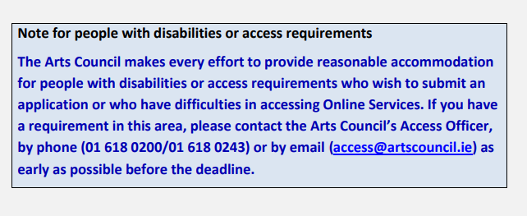
Getting help with your application
If you have questions about using the Online Services website, visit the FAQ section on our website: www.artscouncil.ie/FAQs/online-services/
If you have a technical question about the online application process and your question is not answered in the FAQ section, you can email onlineservices@artscouncil.ie or call the Arts Council on 01 618 0200 or 01 618 0243
To watch our video guide to making an application on YouTube, go to http://www.youtube.com/artscouncildemos
If you have a query about your application that is not technical in nature, you can email or phone the arts team to which you are applying for funding at least forty-eight hours before the advertised deadline. http://www.artscouncil.ie/Contact-us/Staff-and-adviser-lists/

