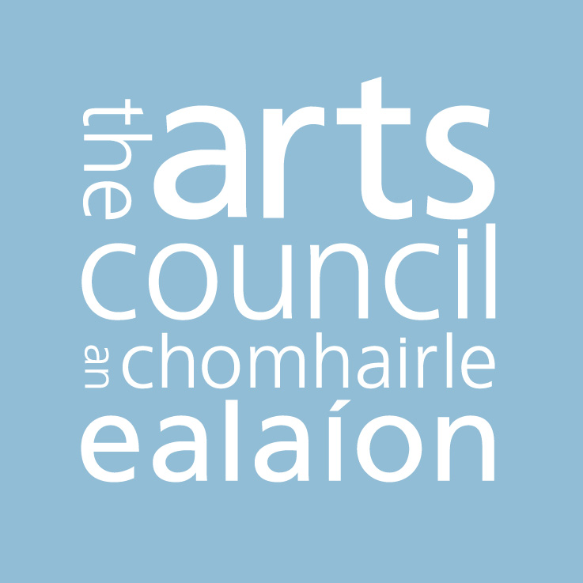

Opera Policy

The Arts Council aims to promote and develop opera in Ireland by supporting opera practice which addresses the twin needs of the public and the artist. Within this context, it recognises that public access is primarily provided for via participation as audience and that the term 'artist' here refers to diverse creative and interpretive practitioners including singers, musicians, composers, librettists, directors, designers and those with opera specific technical expertise. It is only through a constructive engagement with the art form on the part of its composers, performers and other creative artists, and the opportunity for these artists to connect with the public that Ireland can develop a distinctive approach to the art form.

The Council recognises the importance of providing for the longer term development of both audiences and artists by supporting the making and presentation of opera in Ireland across an unrestricted range of scales and types. In so doing, the Council is mindful of the resourcing challenges this objective poses, recognising the reality of costs associated with developing and subsequently sustaining viable business models.

The Council is also mindful of the international context within which opera operates and recognises the importance of opera in Ireland remaining linked into best practice within that international context. The Council will therefore continue to support Irish companies that develop co-producing relationships with a range of companies overseas; will continue to nurture talented opera artists seeking to develop their practice, particularly at the formative stages of their professional practice; and will continue to recognise the benefit that opera audiences in Ireland derive from experiencing the talents of visiting practitioners.

Within the context set out above, the Arts Council's support for opera will include an emphasis on seeking to create and support opportunities for:

- making and presenting work across a range of scales and types in a manner which takes account of both the distinctive context within Ireland and the international environment within which opera operates

- creating and presenting new work that encourages and supports Irish or Irish based composers and writers

- new partnerships that encourage fresh thinking regarding methods of production and dissemination of the art form

- increasing public engagement via the strategic development of audiences for opera.

December 2011

